AutoISF2.2 – Release Notes for Users upgrading from previous versions

The new release includes 3 new features as described in the Quick Guide and as a consequence there were changes in the naming conventions. The term autoISF now addresses all the features as the total concept and the initial autoISF effect of sustained high glucose values was renamed duraISF.
Also some of you got hold of interim versions 2.0 or 2.1 where some names were changed too to specify their use more precisely. This had implications for several of the terms used in weights and menus:

New name | Previous name | Meaning
dura_ISF_minutes | autoISF_duration | Reported in SMB-tab;  how many minutes the glucose was within a +/- 5% range
dura_ISF_average | autoISF_average | Reported in SMB-tab;  the average glucose in the above range
dura_ISF_weight | autoisf_hourlychange | User parameter via menu;  weight for strength of effect
enable_dura_ISF_with_COB | enableautoisf_with_COB | User parameter via menu;  Enable the dura_ISF contribution even with active COB
enable_pp_ISF_always | enableppisf_always | User parameter via menu;  enable postprandial effect all day, not just a few hours after meal
pp_ISF_hours | postmeal_ISF_duration | User parameter via menu;  how many hours the effect will be active after the last meal started
pp_ISF_weight | postmeal_ISF_weight | User parameter via menu;  weight for strength of effect
autoISF_min  autoISF_max | (new, not available before)  autoisf_max | User parameter via menu;  compliments autoISF_max because now ISF can also be weaker
enable_autoISF | use_autoisf | User parameter via menu;  all autoISF effects allowed or none at all

Before you upgrade to the new autoISF you should write down your current values of the user parameters and reassign them under the new names after the upgrade. Because of the name change they cannot be carried forward with the install process neither the settings file. If you forgot to take note you can always go to one of the last logfiles and find the values used at the time. The relevant rows for AAPS2.8.2 start like this:

00:04:58.302 [RxCachedThreadScheduler-4] D/APS: [DetermineBasalAdapterSMBJS.invoke():98]: Profile: {"max_iob":6,"type":"current", …

The other major difference is the way to build the apk. Before I put those 6 files on my Github which were changed and needed to be replaced in the master. Now it is a complete repo and located on the Github of T-o-b-i-a-s, one of the members of the autoISF development team. In case you are unfamiliar how to build an apk from a non-standard repo and on top of that how to do it from a branch here is a short recipe:
- Create a new project in Android Studio. As source you first enter the location of the master GitHub – T-o-b-i-a-s/AndroidAPS
- Wait until all the files from that master have been downloaded and as always reject any proposals to upgrade gradle.
- Next you go to the bottom right corner of Android Studio and find the branch logo together with the name of the currently active branch, in this case it is “master”. Click on it and scroll through the list of available branches until you get to “origin/3.0-ai2.2.6“.
- After clicking it you wait until the project is updated to reflect the autoISF2.2.6 status.
- Now you are ready to build the signed apk as usual.
- Should you get any error messages you can go to the ”Build”-tab again and select “Clean”. This will clean up left overs from previous actions. After that is finished you re-do the ”Build signed apk”.
The screen shot below started from “dev-ai2.2.4” instead of “master” but should help to orientate.
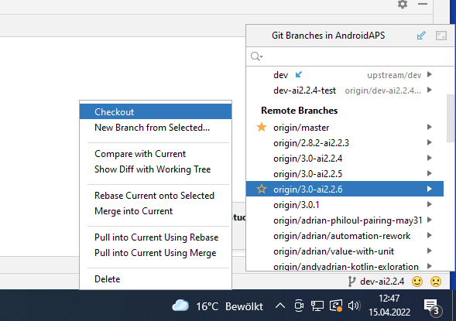

When you run into trouble inside the app first disable autoISF altogether in the “Preferences” so you can check whether it originates from the new AAPS3.0.01 with all its own changes.

Status: 15.Apr.2022

Now all autoISF related variables are in one place, at the end of the Profile listing.
